Assignment Submission Report
Name: Charles Taggart
Course / Cohort: FSDI-113 / CH 65
Assignment: FSDI-113 Assignment 1
GitHub Repository Link: https://github.com/chucktagg83/112-Django.git

Evidence of Functionality

Frontend/UI
Backend/Logic:

Creating New User Account
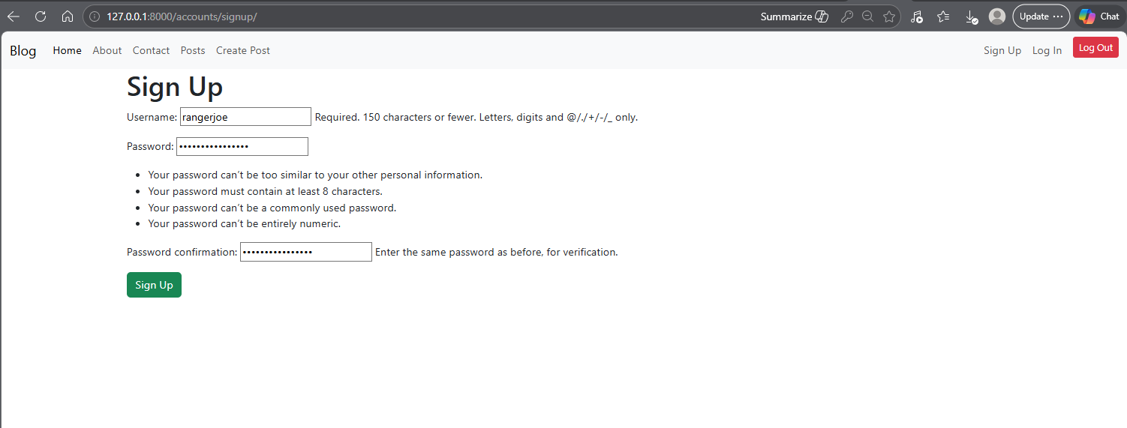
Logging User In
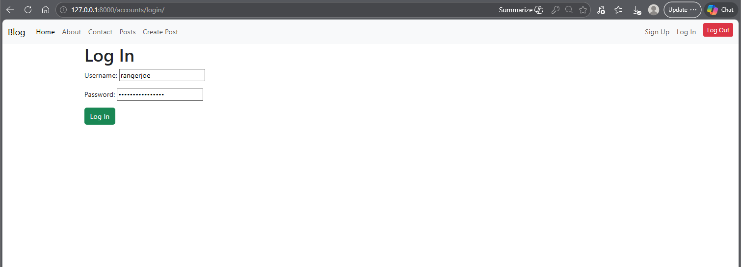
Logging User Out
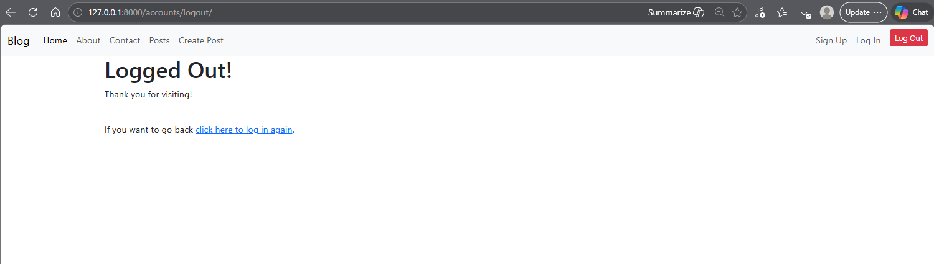
AI Disclosure (Required) – Highlight the one that applies
- I did not use AI
- I used AI for help
- AI generated parts of my code

